The second semester final exam Grade Six

***Question 1: Reading Comprehension ( 12 points)***

**Read the text carefully and answer all the following questions:**

We are having an amazing time on holiday. Dhana Nature Reserve is spectacular and it's very interesting. We arrived here yesterday afternoon. Out hotel is in the mountain. We can sit outside the hotel in the balcony .

This morning, we visited the village of Dhana in Tafilah. Some of the houses and other buildings in Dhana are very old, but people are repairing ***them***. The village has got new street and park. There is a craft's shop in Dhana. You buy food, pictures, toys, clothes, soaps and jewellery .

1. Dhana Nature reserve is in **A.** Azraq **B.**  Tafilah **C.** Ajloun ( 2 points)
2. When did they visit Dhana Nature Reserve? ----------------------------------------------------------------------------------------------------------------------------------------------------------------------- ( 2 points)
3. What can you buy from the craft's shop? A. __________________________

B._____________________________C. ________________________________( 3 points)

4. what does the underlined pronoun ( them ) in the text refer to? _________________________________________________________________( 2 points)

5. where is the out hotel? ___________________________________________ ( 2 points)

6. find a word in the text that means GREAT? ­­___________________________( 1 points)

***Question 2: Focus on Vocabulary ( 11 points)***

1. **Look, match and write** ( 6 points)

Accountant – inventor – architect – knit - mosaics - metal

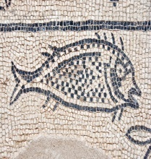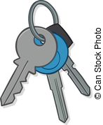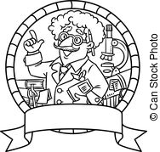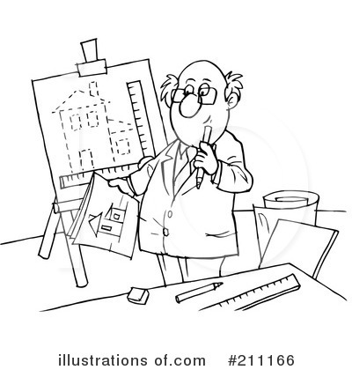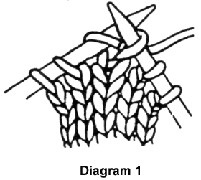

**----------------- ---------­­------------ ­­­ ---------­­------------­­­­­­­­ ---------­­------------­­­­­­­­ ---------­­--------- ---------­­---------**

**B. Read and complete the sentences** ( 5 points)

Was checking- experiment – cedar – extinct - dentist



**The Ministry of Education**

**The Education Directorate of**

**School---------------------**

**Final Exam- Second Term**

**Class: Sixth Grade**   **(Action Pack 6)** **Material: English Language**

**Instructor: Date: 1 \6\2022**

**Time: One hour. أجب عن جميع الأسئلة المذكورة**

**Name: .......................................................................................................................................Section :(..................)**

**PART ONE**

Question One**:** Reading Comprehension (12 points)

-Read the following text **carefully** and then answer all the questions below:

We are having an amazing time on holiday .Dhana Nature Reserve is spectacular and it's very interesting . We arrived here yesterday afternoon. Out hotel is in the mountains . We can sit outside the hotel in the balcony .

This morning , we visited the village of Dhana.Some of the houses and other building in Dhana are very old , but people are repairing them. The village has got new street and park .

There is a craft shop in Dhana .You can buy food, pictures, toys, clothes, soaps, and jewellery.

**1.** Dhana Nature Reserve is in : a. Azraq b. Ajloun c. Tafilah (2 points)

**2.** When did they visit Dhana Nature Reserve? (2 points)

..

**3.** What can you buy from Dhana,s shop ? (3 points)

a-b- c.

**4.** **Find the word in the text which means (amazing**)? (2 points)

**5.** Do you think life will be different in Dhana in the future ? (How) (3 points)

..

**PART TWO**

Question Two: Focus on Vocabulary (11 points)

**A.** Look, match and write: (6 points)

Accountant - recycle  inventor - tour guide – knit - architect

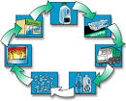 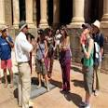 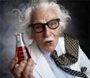

------------------------- ------------------------- ---------------------------

 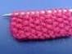 

------------------------- ------------------------- -------------------------

**B.** Read and complete the sentences: (5 points)

dentist , experiment , checking in , cedar , extinct

1. On Lebanon's national flag, there is a  tree **.**

2. Salma started to cry while uncle Hassan  in the airport**.**

3. Ali has got a toothache, he will visit a .. **.**

4. I hope the endangered animal became **.**

5. I need coin, water a bowel for the .

**PART THREE**

Question Three: Focus on Language and Structures (10points)

**A.** Choose the correct answer in the following sentences: (5 points)

1. my grandpa couldnt ----------a mobile when he was young . a. use b. using c. used

2. ..have you studied English? a. How b. How long c. ?

3. Sami wants to .played in a competition? a. be b. was c. is

4. My mum cooked mansafe while I was… . a. play b. played c. playing

5. When Ali was eight ,he could .a bike **.** a. mends b. mend c. mended

**B.** Read and rewrite (How long **+**have ) (3 points)

1. you / played / tennis /

..**?**

2. you / school/ been /at / a pupil/this

.?

3. known \ you/friend/ you/ your/best

.?

**C.** How many **syllables** are there in following words? (2 points)

1. carefully:-. 2. slowly:-..

**PART FOUR**

Question Four: Focus on Writing (7 points)

**A**. Choose the correct punctuations in the following sentences: (1 points)

1. What is the spoon made of. a. **?** b. **.** c. **!**

3. I..m doing a project. a. **?**  b. **'** c. **,**

**B.** Order and write: (2 points) 1) you/ in/ruler/ if/ put/ a/ it/ water/ floats/

..

2) – a/ water/ sinks/it/coin/ you/ in/ put/if

.

Question Five :- Writing (4 points)

There are lots of ways we can help to protect our word

Look at the mind map then write four sentences about (protect our world) :

.......................................................................................................................................................................................................................................

Outside our cities At home

Protecting plants

and animals

Travelling



**The Ministry of Education**

**The Education Directorate of ------------**

**Final Exam- Second Term**

**Class: Sixth Grade**   **(Action Pack 6)** **Material: English Language Date / / 2022:**

**Time: One hour. أجب عن جميع الأسئلة المذكورة**

**Name: .......................................................................................................................................Section :(..................)**

**PART ONE**

Question One**:** Reading Comprehension (12 points)

-Read the following text **carefully** and then answer all the questions below:

My parents friends from England came to visit us last week. They wanted to go to the desert and ride in a hot-air balloon. We were very excited. The balloon was beautiful. It was all the colours of the rainbow. I took some incredible photographs. Im afraid of heights, but I wasn't frightened in the hot-air balloon. I was surprised. I thought it was very exciting. The balloon was very safe and it was very quiet up in the sky.  **(Ghada)**

**1.** Ghada's parents' friends are from: a. Jordan b. England c. Egypt (2 points)

**2.** When was the visit? (2 points)

..

**3.** What did Ghada do when she was in the hot-air balloon? (3 points)

.

**4.** The balloon was all colours of the: a. sky b. desert c. rainbow (2 points)

**5.** What is Ghada afraid of? (3 points)

..

**PART TWO**

Question Two: Focus on Vocabulary (11 points)

**A.** Look, match and write: (6 points)

bench, crocodile, plaster, brochure, slide, glider, toe

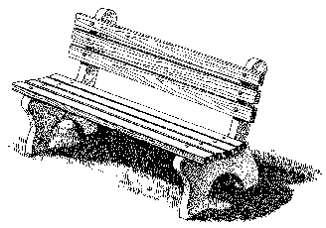

------------------------- ------------------------- -----------------------





------------------------- ------------------------- -------------------------

**B.** Read and complete the sentences: (5 points)

afraid, culture, park, agree, boring, adventure

1. I think watching the news is **.**

2. I loved the slides in the water **.**

3. They have been learning about Jordanian.. **.**

4. Fatima is..of heights and snakes**.**

5. Climbing a mountain is a great.

**PART THREE**

Question Three: Focus on Language and Structures (12 points)

**A.** Choose the correct answer in the following sentences: (5 points)

1. Raed has been…to ride a horse today. a. learn b. learning c. to learn

2. The people are getting..the plane. a. onto b. into c. in

3. Have you.played in a competition? a. never b. ever c. yet

4. Khaled has fallen off his bike. He's hurt… . a. himself b. yourself c. herself

5. We haven't swept the floor. **.** a. already b. never c. yet

**B.** Read and rewrite (**have been + V-ing**) (3 points)

1. I \ play tennis \ today

..

2. I \ swim \ in the sea

.

3. I \ do some homework

.

**C.** How many **syllables** are there in following words? (4 points)

1. crocodile: 3. terrifying:

2. princess:.. 4. lonely:

**PART FOUR**

Question Four: Focus on Writing (5 points)

**A**. Choose the correct punctuations in the following sentences: (3 points)

1. Have you ever swum in the sea. a. **?** b. **.** c. **!**

2. I've never seen a giraffe.. a. **?** b. **.** c. **'**

3. No...I've never visited the Eiffel Tower. a. **?**  b. **'** c. **,**

**B.** Order and write: (2 points) 1) - myself**.** \ I've \ hurt

..

2) - the floor. \ He's \ already \ mopped

.

THE END