

**The Ministry of Education**

**The Education Directorate of /Salt**

**-------------- basic School**

**Second Exam-Second Term**

**Class: Sixth Grade**   **(Action Pack 6)** **Material: English Language**

**Date**

**Time: One hour. أجب عن جميع الأسئلة المذكورة**

**Name: .......................................................................................................................................Section :(..................)**

**PART ONE**

Question One**:** Reading Comprehension (5 points)

-Read the following text **carefully** and then answer all the questions below:

Rakan was in Aqaba with my mother, my father and my brother,Jaber. We wanted to go on a boat trip. I was very excited. The boat arrived. Jaber started to cry while we were walking onto the boat."It's Ok", said Mother .

My mother gave Jaber his toy .There was a noise and the boat started. Jaber was very frightened .

Then ,I had an idea. I took Jaber to the window."We can look at the sea."I said. Jaber smiled .He watched the other boats. The trip was fun

**1.** Rakan was in: a. Aqaba b. Amman c. Dead Sea (1 points)

**2.** Who is in the lesson ? (1 points)

a-……………………………………………b-…………………………………….

**3-** What is the problem with Jaber? (1 points)

……………………………………………………………………………………………………………………………………………………………………

**4.** What happened at the end ? (1 points)

……………………………………………………………………………………………………………………………………………………….

**5.** The underline pronoun refers to…………………… (1 points)

Question Two: Focus on Vocabulary (4 points)

**A.** Look, match and write: (2 points)

Embroider – weave - coach – pot - jug –

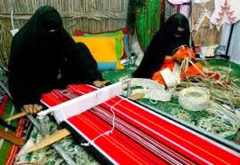 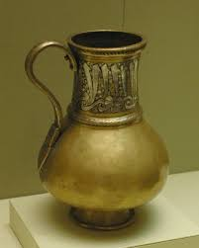 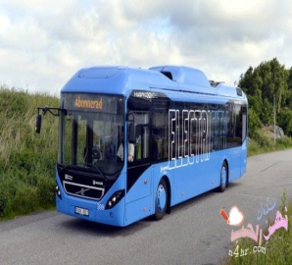 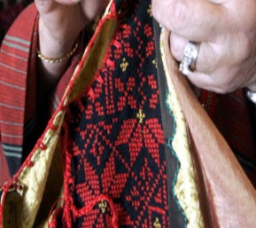

---------------------------- ------------------ ------------------------------- ---------------------------

**B.** Read and complete the sentences: (2 points)

Mosaics - striped- information- gifts

1. In the market, there is…………………………. **.**

2. The museum has lots of ………………………………about Jordan **.**

3. …………………………are part of Jordan's history **.**

4. It's a beautiful, ..…………………….bottle in museum **.**

**PART THREE**

Question Three: Focus on Language and Structures (7 points)

**A.** Choose the correct answer in the following sentences: (4 points)

1. Read …..…………to ride a horse yesterday. a. wake up b. woke up c. woken up

2. The spoon is made of ……………... a. clay b. stone c. metal

3. This ruler is made of ………………… a. wood b. clay c. stone

4. When Grandpa was young, he ---------ride a bike . a. can b. could c. couldn't

**B.** Read and rewrite ( **could +couldn't)+ V** +when (3 points)

1. speak English \ Sami / a baby/he/was.

……………………………………………………………………………………………………………..

2. Ali / swim / old /in the sea/was/ 10 years /he

……………………………………………………………………………………………………………….

3. Mum/ cakes / young/she/was/make

……………………………………………………………………………………………………………….

**PART FOUR**

Question Four: Focus on Writing (4 points)

**A**. Choose the correct punctuations in the following sentences: (1,5 points)

1. Aunt Muna could play tennis when she was young---- a. **?** b. **.** nt c. **.**

2. I couldn--t play chess. a. **?** b. **,** c. **'**

3. No--.she didn't . a. **?**  b. **'** c. **,**

Question Five :- Writing (2,5 points)

Write three sentences about Amman

There's a……………………………………………………………in my bedroom. It's made of…………………………………….

There's ………………………………………………………………………………… ………………………………………………………………………………………………………………………………………………………………………………………………………………………………………………………………………………………………………………………………………………………………………………………………………………………………………………………………………………………………………………

WITH MY BEST WISHES